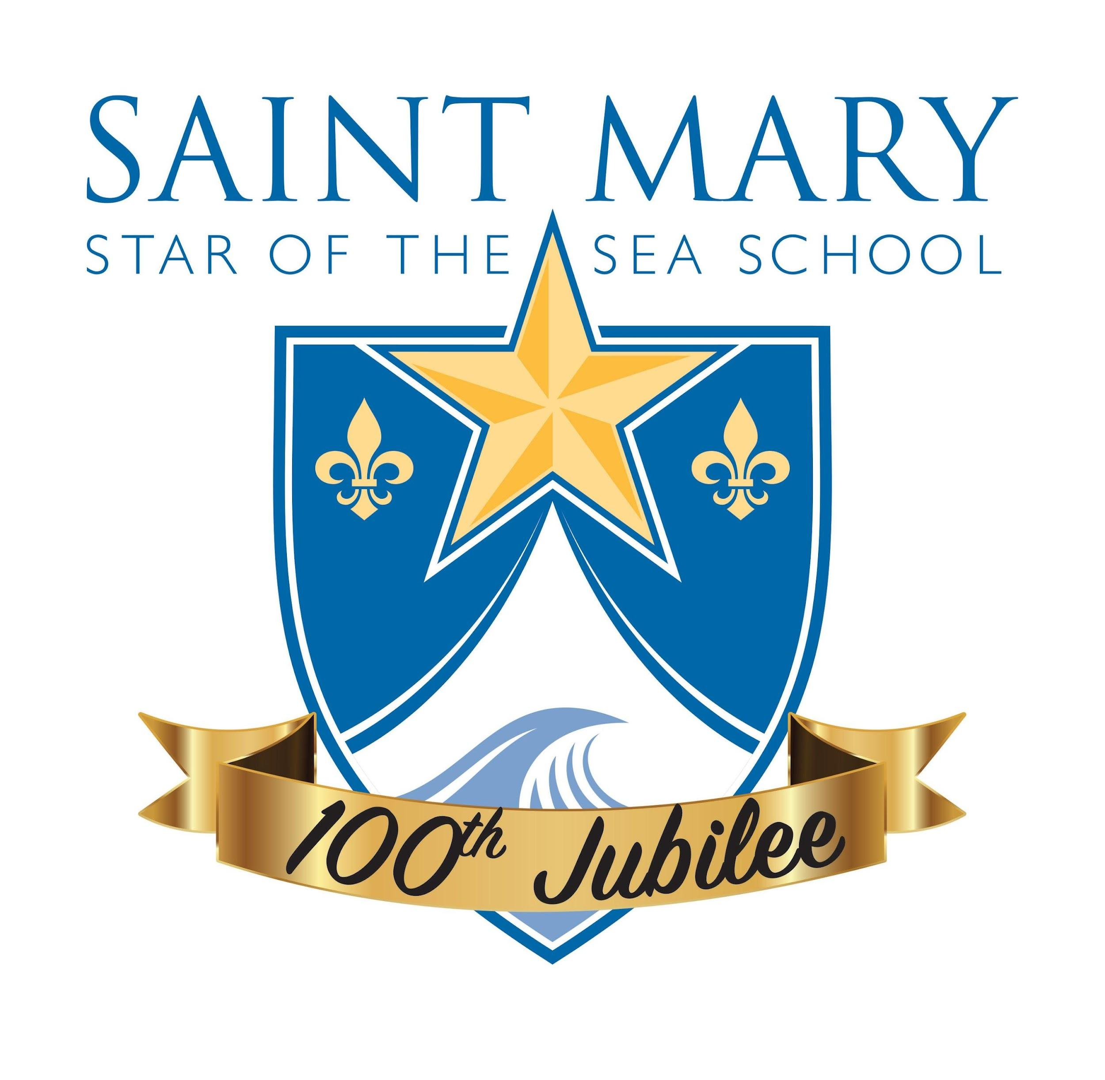
Saint Mary Star of the Sea Uniform Policy

Pre-K 3 and Pre-K4
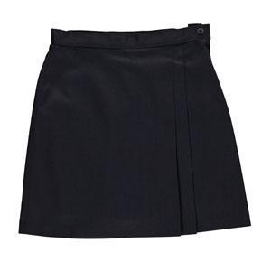
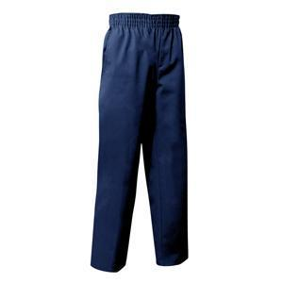
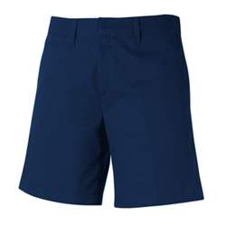
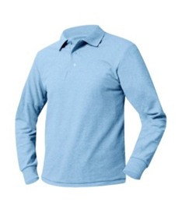
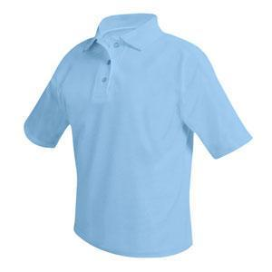

Pre-K boys have the option of wearing either navy elastic waist pants or shorts. Girls have the option of wearing either navy elastic waist pants or skorts. Both boys and girls wear a light blue polo shirt. All wear athletic shoes (no slip-ons) with navy or white socks.

Kindergarten-8th Grade
BOYS:

Pants: Navy blue dress slacks (plain) with a solid navy, black, or brown leather belt.

Shirts:
- Kindergarten-Grade 4: Light blue polo shirt (short or long sleeves, Saint Mary’s logo or plain).
- Grades 5-8: Light blue oxford shirt button-down (short or long sleeves, Saint Mary’s logo or plain). Navy tie that should be close to the length of their belt.

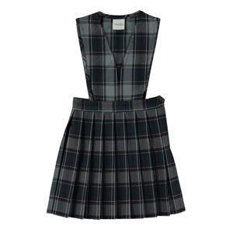
GIRLS:

Jumper: Flynn O’Hara brand for Kindergarten-4.

Plaid skirt: Flynn O’Hara brand for Grades 5-8.
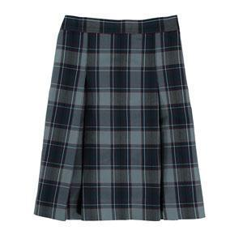
(Skirt length no shorter than 2” above the middle of the knee in the front and back, and shorts must be worn under skirts/jumpers every day.)

Blouses: Only the following blouses should be worn with skirts/jumpers.

Kindergarten-4: White rounded collar blouse-plain (short or long sleeves).

Grades 5-8: Light blue oxford button-down blouse (short or long sleeves, Saint Mary’s logo or plain)
Pants: Navy dress pants are optional from 2nd Quarter and 3rd Quarter and must be worn with solid navy, black, or brown belts and regular blouse or light blue polo.

All Students:

Shoes: PK-3/PK4 athletic shoes only-no slip-ons. Grades K-8 “dirty buck” style tan suede shoes, tan Sperry’s dress shoes only, or nice tan look alike DRESS shoes (no heels). Shoes do not need to be purchased from the uniform company.

Socks: Girls wear plain white or navy knee socks or tights. Boys wear plain white or navy crew socks. No sport socks or anklets.

Sweater: Saint Mary’s navy v-neck pullover sweater from Flynn O’Hara only or navy button-down cardigan-plain or with St. Mary’s logo or Saint Mary’s vest (Girls 5-8).

Sweatshirt: A navy crewneck sweatshirt with Saint Mary’s logo may be worn over blouses/shirts.

Jewelry: One simple ring and one simple chain with religious medal or cross.
Girls may wear a single pair of post earrings in the earlobes. Boys may not wear earrings. No other piercings allowed.

Hair: No unusual or distracting hair styles, dye or hair coloring/highlighting. Hair accessories should be limited to small, simple, solid color, navy, white or uniform plaid headbands/bows only. Boys’ hair should be above the eyebrow, above the top of the ear, and above the collar. Girls’ hair should be out of the face.

Summer Uniform Option: The beginning of the Year until Nov. 1 and after Easter

Shorts: Navy from Flynn O’Hara Uniform Co. only.

Shirts: Light blue polo shirt, plain or with Saint Mary’s logo. No oxford shirts or blouses. (Polo shirts are NOT to be worn with skirts/jumpers).

P.E.:

Athletic shoes are required for P.E. Students should wear athletic shoes to school on P.E. days. Athletic shoes should have laces, no slip-ons.

Students in grades 5-8 are required to change into gym clothes. Gym clothes are to be purchased from Flynn O’Hara Uniform Co.

Out-of-Uniform Days:
The school dress code applies to out-of-uniform days. General regulations and jewelry regulations apply. The following may not be worn:
- Clothing printed with inappropriate advertisements
- Midriff-baring shirts/spaghetti straps/tank tops or immodest clothing
- Sweatpants, leggings without a long shirt (to knee) covering
- Sagging pants or pants without belts
- Torn, ripped, ragged, or tight-fitting jeans or pants
- Make-up/nail polish
- Spandex
- Short shorts/miniskirts (must be 2” above the middle of the knee or longer)
- Flip-flops or high heels
- Visible straps from undergarments
- Hats

