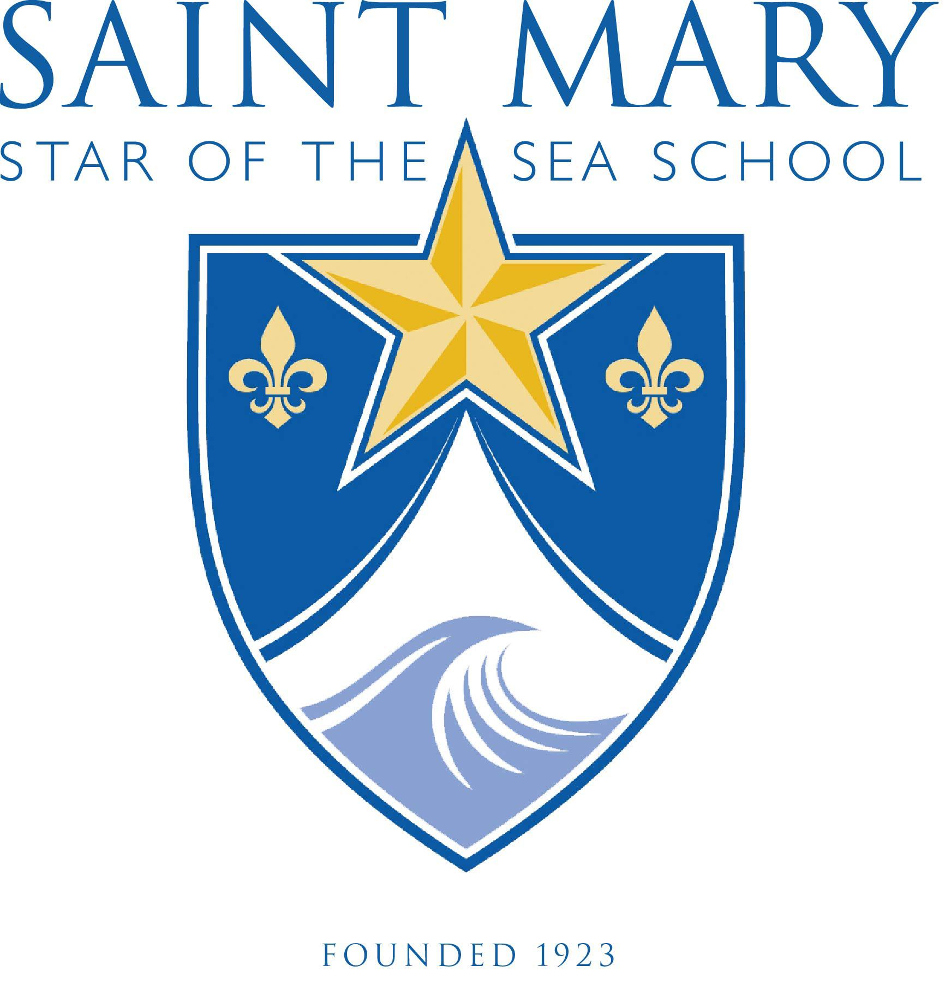
Student Record Release Form
To the Parent or Guardian:
Please fill in the information below as the application cannot be processed without this information. Saint Mary Star of the Sea Catholic School will then forward this request to the school listed below.

Applicant’s Full Name: _______________________________To enter grade: _______

Current School: ______________________________________Current grade: _______

Street address of current school: ___________________________________________

City: _______________ State: _________________ ZipCode: _______________

Parent Permission to Release Records
In accordance with the Family Rights Privacy Act of 1974, permission is granted to release the standardized test scores, scholastic record/transcript, health records, and discipline files if applicable, or any other pertinent information of my child who has applied to Saint Mary Star of the Sea Catholic School.

___________________________ _____________________________ ___________
Parent Printed Name Parent Signature Date

To the receiving school or educational agency:

The student named above has applied to Saint Mary Star of the Sea Catholic School for the ___________ school year. Please send copies of the following information to:

Administrative and Admissions Assistant, ATTN: Kristina Stewart
14 N. Willard Avenue. Hampton, VA 23663
757-723-6544 (FAX)

- Transcript/Report Cards and Academic Records to date
- Attendance Records to date
- Standardized Test Records
- Health and Immunization Records
- Discipline Records
- IEP/504/Special Education Records, if applicable
- Psychological Profiles, if applicable

