**ATHLETIC Handbook**

**2016-2017**

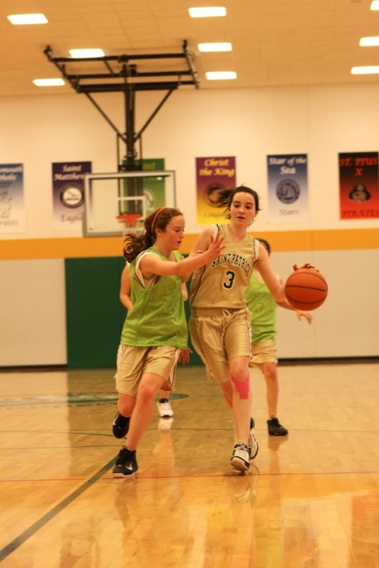

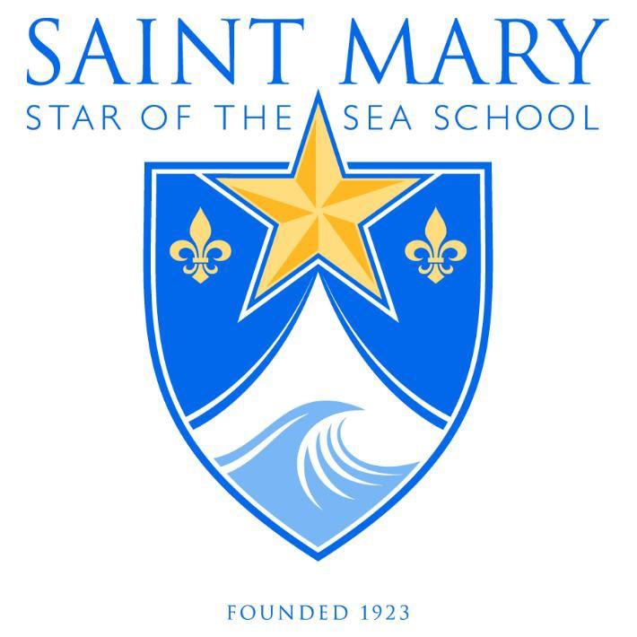



14 N. Willard Avenue, Hampton, VA 23663-1799

phone: (757) 723-6358 fax: (757) 723-6544 saintmarystarofthesea.com

**Contact and Staff List**

14 N. Willard Avenue

Hampton, VA 23663-1799

Phone: (757) 723-6358 Fax: (757) 723-6544

saintmarystarofthesea.com

**Principal**

Sister Mary John

[principal@saintmarystarofthesea.com](mailto:principal@saintmarystarofthesea.com)

**Director of Athletics**

Malik Salaam

[m.salaam.smss@gmail.com](mailto:alynch@stpcs.org)



14 N. Willard Avenue, Hampton, VA 23663-1799

phone: (757) 723-6358 fax: (757) 723-6544 saintmarystarofthesea.com

Dear Parents/Guardians,

Welcome to the athletic program at Saint Mary Star of the Sea School. We hope that all of your athletic experiences will be positive, and that you, as well as the school will benefit from your involvement in the athletic program. Please take the time to read this entire handbook so that you will have an understanding of our athletic policies, requirements, rules, and expectations.

Participation in athletics is a privilege offered to the students of Saint Mary Star of the Sea School. A Saint Mary’s athlete has to be dedicated, enjoy being challenged, and give 100% every day on and off the field. An athlete must strive to do well in the classroom and must maintain the academic requirements. The teachers, coaches, and administrators of Saint Mary’s are committed to helping each athlete to be the best they can be. Each athlete must make the same commitment.

As educators we, who are concerned with the educational development of young people through athletics, feel that a properly controlled, well-organized athletic program meets the student-athletes needs for rigorous fitness, relevant to their future in any professional area, and gives them the ability to develop relationships in several settings. It is our hope to maintain a program that is sound in purpose and will further each student-athlete's educational maturity.

A student-athlete who elects to participate in athletics is voluntarily making a choice of self-discipline and dedication. These are the reasons we place such emphasis on good training habits. Failure to comply with training and self-disciplinary rules may result in the consequences and penalties outlined in this handbook. There is no place in athletics for student-athletes who will not discipline their minds and bodies for rigorous competition or demonstrate appropriate behavior and/or sportsmanship. We are striving for excellence and do not want our student-athletes to settle for mediocrity. When your son/daughter participates in athletics at Saint Mary Star of the Sea School our staff will strive to provide your son/daughter with: Adequate equipment and facilities; the best teaching and coaching personnel possible and equalized contests with skilled officials;

Similarly, we feel you have assumed certain responsibilities and obligations when you permit your son/daughter to compete. We take this opportunity to acquaint you with the rules and regulations of our athletic program. Please read it over carefully. We thank you for your time and commitment to the Saint Mary’s Athletic Program.

Sincerely,

Malik Salaam

Saint Mary Star of the Sea School

Athletic Director

**School Mission & Vision**

**Mission**

Saint Mary Star of the Sea Catholic School educates students of all faiths from Pre-K3 through 8th grade in knowledge and love of Jesus Christ. Under the leadership of the Dominican Sisters, the school develops the spiritual, intellectual, and social aspects of the students, preparing them for high school and beyond.

**Vision**

Saint Mary Star of the Sea Catholic School will remain unparalleled in its academic excellence in a faith-based and disciplined learning environment. Saint Mary's academic offerings will span beyond the classroom to include a unique Marine Science program that enables students to benefit from the natural wonders of the school's living shoreline. While retaining small class sizes with instruction from licensed teachers, the school will offer one of the most sought after educational experiences in Hampton Roads, particularly in the areas of STEM (Science, Technology, Engineering, and Mathematics).

**School Philosophy**

Saint Mary Star of the Sea Catholic School exists to provide a Christ-centered atmosphere in which students may grow in truth and love. Through study of the Gospel of Jesus Christ, this school fosters lifelong learning in discipleship. Its learning environment is directed toward the spiritual, intellectual, and social development as well as the physical well-being of each student and family.

Saint Mary Star of the Sea Catholic School provides an integrated curriculum that accommodates the diversity of learners in a global society while preparing them for eternal life. Teachers address the multiple intelligences of our students by incorporating a variety of learning activities. Every effort is made to teach the whole child and provide a relevant education to prepare them for everyday life. The families of Saint Mary Star of the Sea School are an important aspect of the school community. Forming a partnership with the school, families play an active role in the education of their children.

The faculty and staff live the faith and witness it to their students. They provide opportunities for their students to express the faith with the celebration of Mass, prayer (private and communal), and the integration of the faith within every subject taught. Virtues are studied and applied on a daily basis. The faculty and staff strive to reflect Christ and His teachings in their thought, words and actions.

**Athletic Mission**

At Saint Mary Star of the Sea Catholic School, we believe that athletic participation serves as an important part of a child's education and can provide an exceptional paradigm for life. That's why we encourage all students to participate in athletic activities when and where possible.

There is a wealth of wisdom to be learned that is unique to the athletic arena or playing field. The qualities of physical discipline, team building, winning with humility, losing with dignity, learning from mistakes, courage and pride of accomplishment are just a few of the important values that will be taught and learned through athletic competition.

Saint Mary’s will offer athletic opportunities that allow the greatest participation from the student body. Additional sports and athletic club activities will provide students of all ages with a fun, educational and well-rounded school experience.

**Principles of Good Practice**

**Student-Athlete**

* Student-athletes should always conduct themselves appropriately at games and behave in a Christian manner
* Respect any call of the officials and thank them after the game has ended
* Live up to the standards of sportsmanship established by the school administration and the coaching staff
* Represent Saint Mary Star of the Sea School in a positive manner and understand the seriousness of responsibility and the privilege of representing the school and the community
* Dedicate self to strong effort for improvement of skills, team spirit, and sportsmanship
* Be well groomed and wear the team uniform as instructed by the coach
* Care for and return any uniform items to the Athletic Department at the conclusion of the sport season
* Treat opponents the way you would like to be treated

**Parents/Spectators**

* Parents and spectators are at the athletic event to support the team and to enjoy the skill and competition, not to intimidate or ridicule the other team or its fans.
* Remember that school athletics is a learning experience for students and that mistakes are sometimes made.
* Praise student athletes in their attempt in order to help them improve.
* Represent Saint Mary’s School in a positive manner.
* Learn the rules of the game.
* Show respect for the opposing players, coaches, and spectators.
* Respect the integrity and judgment of game officials.
* Recognize and show appreciation for an outstanding play by either team.
* Use only cheers that support and uplift the teams involved.
* Be a positive role model at events through your own actions.
* Respect the buildings and property of the facilities that are used by picking up trash and following rules as displayed.
* Ensure the safety of children who are spectators by supervising inside and outside of the facilities.

**Saint Mary Star of the Sea School Athletic Program**

Athletics are an important part of the total school program at Saint Mary Star of the Sea School and works in conjunction with the other educational experiences to provide students the environment and opportunity to develop the values of character and ethical decision-making. The opportunity to participate in interscholastic athletics is a privilege that carries with it responsibilities to the school, the sport, other students, the family and the community, as well as the student athlete.

* 1. The school’s athletic program embodies the mission, philosophy, and objectives of the school. The athletic department ensures that coaches have appropriate training and knowledge of the school’s mission. School wide we are committed to the safety and the physical and emotional health of the participants in the athletic program.
  2. The Saint Mary Star of the Sea Athletic Code shall govern all student athletes, on and off campus, during the time they are participating in an athletic program as identified and created from time to time at Saint Mary Star of the Sea.
  3. The purpose for the addition of the athletic program at Saint Mary Star of the Sea is to add to our student’s mental, physical, social, emotional, and ethical wellbeing. It is another step in fostering our student athlete’s to become productive young adults in society.
  4. The participation in athletics at Saint Mary Star of the Sea School is a privilege and not a right. In the exercise of this privilege, all students shall comply with the Saint Mary Star of the Sea Athletic Code of Conduct. Before participating in the student athlete’s first scrimmage or contest of each season, the student and his or her parent/guardian must acknowledge receipt of, and free to abide by, the Athletic Code of Conduct by signing and returning the acknowledgment form to the Athletic Department to be placed in their file.

**Athletic Program Goals**

• The first goal of our program is to develop character.

• The second goal of our program is to improve preparation, commitment, and participation. This will create enthusiasm within the program and community.

• The third goal of our program is to provide student athletes with the necessary tools to prepare physically, emotionally, and mentally.

• The final goal of our program is to develop champions on and off the field.

**Athletic Philosophy**

* Athletics is an important and vital part of the total educational program at Saint Mary Star of the Sea Catholic School.
* The athletic program and the academic program both serve the same purpose-to build character and to give each student qualities that will equip him or her for productive life.
* Saint Mary Star of the Sea School believes in the scholar-athlete. The person who places academics first, but who participates in athletics is a valuable and necessary part of the learning experience in school.
* Saint Mary Star of the Sea School seeks to encourage as much participation as possible at each level of interscholastic competition.

**Academic Eligibility**

It is the intent of Saint Mary Star of the Sea School to provide opportunities for extracurricular activities to those students who are making solid academic progress. While these activities are important, the student's academics should be given **FIRST** priority.

**Saint Mary Star of the Sea Academic Requirements**

Students on academic or discipline probation may be restricted by the school from participating in athletics. Students must carry a normal class load unless otherwise noted by Administration. Students must maintain grades and conduct in accordance with guidelines found in the Parent Student Handbook and in regular attendance of Saint Mary Star of the Sea School.

***Eligibility for try-outs***

Students must be in good academic and behavioral standing on the day of try-outs. Students who are ineligible will not be allowed to try-out at a later date.

***Quarter Eligibility***

Each quarter the student athlete must submit a copy of their progress report and report card to the Athletic Director within two school days of grades being distributed. Students obtaining two D’s or one F on a report will be benched until grades are brought to passing. Students on academic probation will be expected to be at practice at least two times a week and must be in full school uniform sitting with their team for all home games.

Failure to submit the grades to the Athletic Director will result in the athlete sitting out the next scheduled competition.

***Behavior and Citizenship Standards***

Student athletes are required not only to perform academically, but are required to maintain good behavior and conduct in and out of the classroom. When an athlete displays behavior that violates the Schools Code of Conduct, the student will meet with the Discipline Committee and consequences will be decided, which may include but not limited to, games suspensions, travel suspensions, or removal from the team.

**Attendance Eligibility**

Students are expected to attend school on a regular basis. Students must be in school on game day by 11:00 am unless excused by a doctor. Students who are habitually absent or late face the possibility of removal from the team. If a student is absent from school due to illness on game day, they may not participate in that days game. Athletes, who are absent from school for reasons other than illness, will have their eligibility left to the discretion of the administration. Practice is mandatory unless personally excused by the coach.

**Missing practice**

An athlete should always consult his/her coach before missing practice. Missing practice or a game without permission from the coach will result in a loss of play during the next scheduled competition.

**Early Dismissal for Athletes**

Students are responsible for ALL missed work due to early dismissals for traveling to the scheduled events. Students are required to follow the following guidelines:

1. Obtain all work and assignments for classes to be missed.
2. Turn in all work when due.
3. Make up any missed test or quizzes.
4. Student athletes who fail to abide by the conditions of early dismissal for events are subject to a possible academic penalty at the discretion of the teacher/administration or the loss of practice and game time until all academic work is current or both.

**Conflicts in Extracurricular Activities**

An individual student who attempts to participate in several extracurricular activities will undoubtedly be in a position of a conflict of obligations. The athletic department recognizes that each student should have the opportunity for a broad range of experiences in the area of extracurricular activities, and to this end, will attempt to schedule events in a manner to minimize conflicts. Students have a responsibility to do everything they can to avoid continuous conflicts. This would include being cautious about belonging to too many activities where conflicts are bound to happen.

Students may not play two sports at the same time with the exception of running cross country while playing soccer or volleyball. Students who wish to be involved in after-school clubs must clear practice times/days with their coaches.

**Safety**

The Athletic Director and coach must be notified in the event of any injury that occurs at a school-affiliated sporting event. Medical release forms will be given to all coaches that provide information on reaching parents and emergency contacts in case of an incident.

**Transportation**

The school relies on athlete transportation to away competitions. Drivers must complete the required volunteer paperwork before transporting students. All athletes must be picked up by a parent or guardian from the home/away competitions.

**Directions to Away Competitions**

Parents will be provided directions to all away competitions. Directions can also be found on the school website.

**Team Rosters**

The number of athletes on each team will vary. The head coach of each sport will determine how many student-athletes each team will carry.

**Team Selection**

* Tryouts are open to all eligible students.

* Students who are enrolled in Saint Mary’s before the first game of the season will be eligible to try out for that sport. Students who enroll after the first game will not be eligible to try out.

**Equipment and Uniforms**

* Uniforms are the property of Saint Mary Star of the Sea School.

* Uniforms will only be worn during the competition. Students may not wear them over their school uniforms on game day. Students will be allowed to wear team sweatshirts any game day of the week during the season and on any Friday during the school year as spirit wear.

* Students must pay for any lost or damaged equipment and uniforms. The school will not release grades, report cards, test scores, transcripts, awards, or diplomas until all holds are removed from the student’s account.

**Multi-Sport Athletes**

A player committed to one sport may notquit during the season to participate in another sport until the conclusion of the original sport’s regular season and post season play.

**ATHLETIC TEAMS**

**Fall Sports**

**Co-Ed Soccer 5th-8th Grade Boys and Girls**

* All student’s interested in trying out for the Saint Mary Co-Ed Soccer team MUST be in good academic standing before trying out.
* Complete a registration form with payment.
* Be able to commit to the sport without interruptions
* A uniform will be provided for each member on the team
* Players must purchase cleats, shin guards, and socks (color assigned by the coach).

**Cross Country 5th – 8th Grade Girls and Boys**

* All student’s interested in trying out for the Saint Mary Cross Country team MUST be in good academic standing before trying out.
* Complete a registration form with payment.
* Be able to commit to the sport without interruptions
* A uniform will be provided for each member on the team.
* Players must purchase running shoes.

**Volleyball 5th – 8th Grade Girls**

* All student’s interested in trying out for the Saint Mary Volleyball team MUST be in good academic standing before trying out.
* Complete a registration form with payment.
* Be able to commit to the sport without interruptions.
* A uniform will be provided for each member on the team.
* Players are required to purchase knee pads and sneakers.

**Winter Sports**

**Basketball 5th – 8th Grade Boys and Girls**

* All student’s interested in trying out for the Saint Mary Basketball teams MUST be in good academic standing before trying out.
* Practice start in the middle of October and runs until the middle of February.
* A uniform will be provided for each member on the team.
* Be able to commit to the sport without interruptions.
* Complete a registration form with payment.

**Spring Sports**

**Baseball 5th – 8th Grade Boys**

* All student’s interested in trying out for the Saint Mary Baseball teams MUST be in good academic standing before trying out.
* Practice start in the middle of February and runs until the end of April.
* The school provides the top of the uniform and a hat for every player.
* Each player will need to provide a glove, cleats, pants, belt and socks.
* Complete a registration form with payment.

**Softball 5th – 8th Grade Girls**

* All student’s interested in trying out for the Saint Mary Softball teams MUST be in good academic standing before trying out.
* Practice start in the middle of February and runs until the end of April.
* The school provides the top of the uniform for every player.
* Each player will need to provide a glove, cleats, pants, belt and socks.
* Complete a registration form with payment.

**Coaches and Volunteers**

All coaches are volunteers. They are able to create their own practice times by availability of both the coach and the playing areas.

All head coaches, assistant coaches, and team parents (as well as any other volunteer in a position working directly with our students) are required to:

1. Attend a VIRTUS child protection training session (register at virtusonline.org) as well as a background screening form.
2. Attend a coaches’ meeting at the beginning of each new season. At this meeting, coaches receive league information, Saint Mary’s communication policy, medical release forms for athletes, and information pertaining to our student-participation philosophy.

**Communication**

All communication should go through the school’s Athletic Director to be previewed.

Please remember to respect the confidentiality of all players, coaches, and parents when preparing a communication.

**Cancellations**

In the event that the practice fields are closed or games are cancelled due to weather or other reasons, the athletic department will immediately send out an email to all coaches and inform the office. The school will be responsible for contacting parents to notify them of any changes.